**Background Information**

STIPA through support from BROOKE EA under the *Tunza Punda Inua Jamii* project implements the following activities, mobilizing the youth, (men and women) in rural agricultural and peri-urban areas, train on proper care of donkeys for optimum working efficiency and financial returns, build of donkey owners on donkey care, facilitation of prompt veterinary Services, facilitate community-based livestock health insurance scheme. STIPA works with the county governments of Kisumu and Siaya Counties to support the donkey owner’s association and develop a legal framework of policies for protection and care of donkeys in Rarieda sub-counties/Migwena and Uyoma Kisumu County Nyakach and Seme sub-counties. Target number of beneficiaries are 300 Donkey owners and users in the two counties, 1800 Indirect beneficiaries (Youth, Juakali artisans, women and children), promote and adopt Animal Welfare Standards. Community advocacy against donkey theft, slaughter and unethical welfare practices. in advocacy against the slaughter of donkeys DHT (Donkey Hide Trade). contribution to the ban of donkey slaughter in the abattoir in Kenya.

**PHOTO GALLERY**

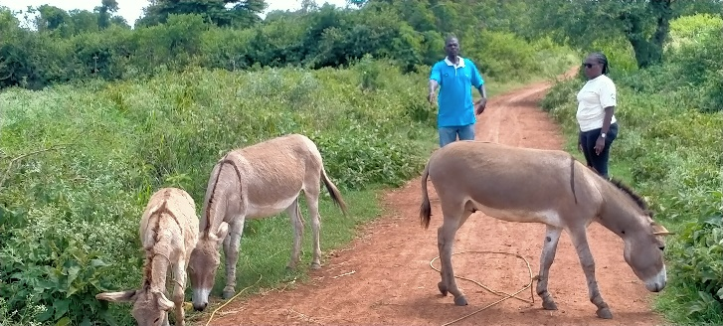 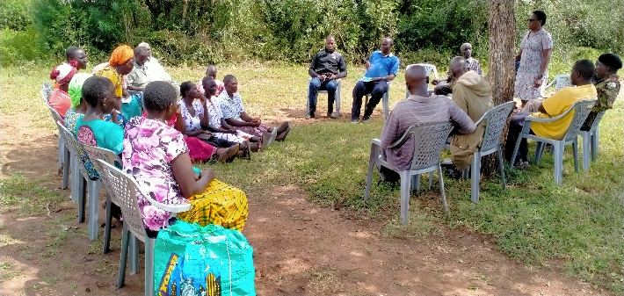

Figure 2: Damaris Adhiambo, STIPA P.O engaging stakeholders & donkey owners on issues of security and donkey welfare during a sensitization session in Migwena on 17th September 2020.

Figure 1: Damaris Adhiambo, STIPA P.O Siaya conversing with a donkey owner in Sakwa, Bondo during the baseline survey on 6th August 2020.

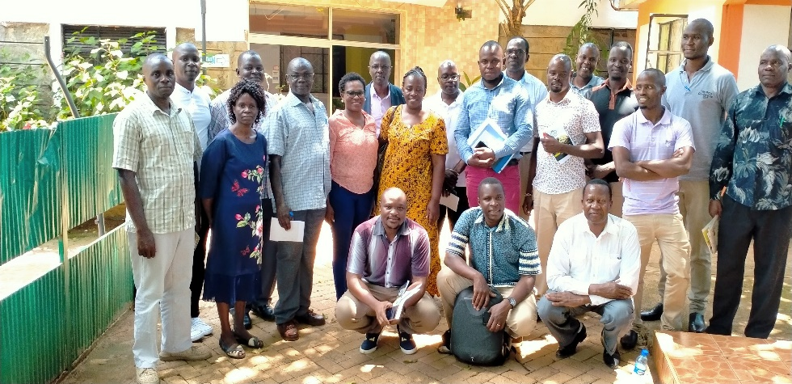Figure 3: A group photo of STIPA’s project implementation team including other stakeholders, Kisumu and Siaya county government officials.

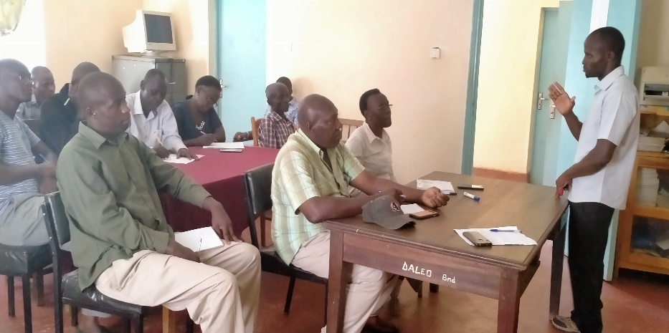 Figure 4: SCVO Kisumu Morvan, addressing leaders of Community Action Groups, donkey owners and stakeholders in one forum Bondo for formal engagement on 14th August 2020.